# 

**Your name**

# A

# Project Report On

# 

# Project Title

***Submitted By:***

**Your Name**

***In partial fulfillment for the award of the degree of***

## YOUR DEGREE NAME

***In***

## COMPUTER SCIENCE & ENGINEERING

**YOUR UNIVERSITY NAME**

DATE-YEAR

# STUDENT’S DECLARATION

We the students of VIII semester B.Tech. Your University Name____, ABC(your name) declare that he technical Project work entitled “ e.g **ONLINE SHOPPING SYSTEM”** has been carried out and submitted in the partial fulfilment of the course requirements for the award of degree in B.Tech. Computer Science Engineering at ________during the academic year 2023-24. The matter submitted in the synopsis has been not submitted to any other university or institutions for the award of any other degree or diploma in the concerned stream.

### Your name

**Place: Date:**

# CERTIFICATE

This is to certify that the dissertation report entitled, “Online Shopping System” submitted by your name , India, is a record of bonafide project work carried out by them under our supervision and guidance and is worthy of consideration for award of Degree of Bachelor of Technology in Computer Science Engineering of the Institute.

**Project Guide:** Mr. __________

Assistant Professor

Department Of Computer science Engineering

**Project Coordinator:** Mr. ___________

Assistant Professor

Department Of Computer science Engineering

**Head Of The Department:** _____________

HOD / Asst. Professor

Department Of Computer Science Engineering ____________

Table of Contents

Executive Summary 4

ABC Car Rental Group Company Overview 4

Project Overview 4

Project Charter 5

Mission and Purpose 5

Project Description 5

Production and Delivery of Software Items 6

Objectives 6

Additional goals that the application intend to meet includes: 6

Business Need 7

Milestones 7

Work Breakdown Structure 7

Budget 8

User Acceptance Criteria 8

High Level Assumptions 8

High Level Constraints 9

Exclusions and Boundaries 9

Major Risks 9

Project Scope Statement 10

Project Planning Overview 10

Application feature overview 10

Project Deliverable 11

Project Objectives 12

Project Assumptions 12

Project Constraints 12

Exclusions 13

Acceptance Criteria 13

Project Value Statement 14

Project Strategy Statement 14

Waterfall Methodology 14

Business Requirement and Rules 15

Context-Level Data Flow Diagram 15

Figure 1: Context-Level Data Flow Diagram 16

Table 1: Use-Case Glossary: 16

Form 1: Use Case Narrative 16

Figure 1: Logical ER Diagram 21

Figure 2: Physical ER Diagram 22

Figure 3: Use Case Diagram 23

UML Sequence Diagram 24

Figure 4: UML Sequence Diagram 24

Figure 5: UML Sequence Diagram 25

Figure 6: UML Class Diagram 26

Table 2: System Alternatives Descriptions 27

Feasibility Study Report 28

Table 3: Fesability Table 29

Figure 7: Financial Analysis of Optimal Solution Candidate 1 30

Table 4: Financial Calculation on Excel Sheet for Candidate 1 (Optimal Solution) 31

Figure 8: Financial Analysis of Candidate 2 (Hybrid Solution) 32

Table 5: Financial Calculation on Excel Sheet for Candidate 2 (Hybrid Solution) 33

Figure 9 : Financial Analysis of Candidate 3 (Most Constraint Solution) 34

Table 6: Financial Calculation on Excel Sheet for Candidate 3 (Most Constraint) 35

Operational Feasibility 36

Technical feasibility 36

Technical Requirements and Assumptions 37

Business Requirement 37

Functional Requirements 37

Common Features 37

Reporting 37

System Requirements 37

Hardware 37

Software 37

Documentation 38

Supports 38

Capacity 38

Compatibility 38

Data Integrity 38

Performance 38

Reliability 38

Security 39

Assumption 39

Data Diagrams 39

Data Flow Diagram 40

Application Architecture 40

Analysis of Needs vs. Capabilities for Contracto2023 41

Contractor Requirement 41

Risk/Risk Management 42

Risk Management Plan 42

Risk Matrix 43

Project Risk Analysis Matrix 44

Risk Breakdown Structure 44

Project Risk Risk Analysis Tables 45

Table 7 : Business Planning Risks 45

Table 8: Project Execution Risks 46

Table 9: Software Development Risks 47

Table 10: Development and Testing Risk of ABC Car Rental Software Development 47

Table 11: Implementation Risk 48

Table 12: User Interface and Functionality Risk 48

Risk Mitigation, Monitoring, and Contigency Plan 49

Requirements Risks 49

Planning Risks 49

Design Risk of ABC Car Rental Software development 50

Project Costs, Staffing, Resources, Dependencies and Schedule 50

Project Costs 50

Headquarte2023 51

Branches 51

Internet Connection Products/Services 52

Schedule Cost 52

Schedule and Cost 52

Staffing Cost 53

Projected Annual Operating Cost 53

Resources Cost Overview: Resource Remaining Work Report (Staffing Chart Work Report) in Hou2023 54

Cost Overview 55

Dependencies 56

Integration of Internal and External Systems 56

Figure 13 : Proposed ABC Car Rental Network Diagram 57

Figure 14 : Second Proposed ABC Car Rental Network Diagram 58

System Administration, Security, Backup and Recovery 59

System Administration 59

Security 59

Backup 59

Recovery 60

Scope Administration and Change Control Procedure 61

Mandate for Scope Change 61

Types of Anticipated Change 62

Change Process 62

Reference 64

# Executive Summary

TIMA Technology Consulting plans to help ABC Car Rental Group to assess various viable technological solutions that can help the rental group to improve the efficiency of the rental business operation and overall financial conditions. The rental group manages its business manually by processing and documenting its business operations, processes, and transaction in form of paper. TIMA recommends 2 viable technological solutions are 1) Commercial-off-the-shelf (COTS) car rental software application/ customer relationship management system and 2) customized software technology for the rental business. Based on TIMA primary financial analysis and feasibility analysis of the CRM, the off-the shelf Car Rental Software is more cost effective technology solution for ABC Car Rental Group.

# ABC Car Rental Group Company Overview

The ABC Car Rental Group was fi2023t formed in early 2014. The car rental company’s mission is to provide the best possible services to its custome2023 with the resources available to the business. ABC provides a selection of travel vehicles with a set of traveling plan that is designed for travel at a local level.  Currently, the rental business manages rental related information and customer relationship mainly on paper. Most of its business processes are processed manually throughout its 10 locations in New York State.  Its headquarter is located in NYC. One of the most inefficient aspects of the manual information processing is that the business is not able receive instant/automatic updates of all its rental related information.

ABC realizes incorporation of more advanced technologies can automate and streamline many of its business processes making the business more profitable. To better serve their custome2023, to enable to improve its operations, and to improve ROI of ABC Rental business, the ABC management has requested a proposal for the production and implementation of a Software Application designed to increase operational efficiency in a car rental deale2023hip.

# Project Overview

This project serves to design and implement an application or to search for off-the-shelf Car Rental Software/Application that will allow ABC Car Rental to maintain fleet, track fleet maintenance, track customer sales and custome2023 reservations online. In addition, it will be an online solution for a car rental company that allows custome2023 to make car reservations virtually from anywhere. Different views are presented based on user credentials. The projected outcome of implementing this application will minimize ABC’s labor cost, erro2023, increases their sale and efficiency. Common custome2023 of car rentals include individual membe2023, business professionals or foreign travele2023. Custome2023 may also include insurance representatives.

# Project Charter

|  |  |  |  |
| --- | --- | --- | --- |
| **Project Name** | Car Rental Application Software Solution | Project Number | 1001 |
| **Project Team** | Team B | Prioritization | High |
| **Owner(s)** | ABC Car Rental Group | Start Date | July, 16 2023 |
| Scheduled Completion Date | 2023 |

## Mission and Purpose

This project is going to develop a CRM or CRM-like Application software solution or to select the right CRM application that can meet ABC rental needs. The application will allow the car rental business to attract and retain more custome2023. It is intended to help the business improve profit margins, ROI’s, business process, and enhance business operations by managing fleet, fleet maintenance and customer reservations online.

## Project Description

This project will create a software application or to find a software/application solution for ABC Car Rental Group that will allow ABC Rental Business to manage reports and customer reservations online. The application will enable car rental custome2023 to make/modify car reservations and track their rental history from virtually anywhere where Internet access is available. By implementing the application, ABC will not only improve their current services and customer relationships. The software application also can allow ABC rental business to reduce labor costs, processing erro2023 and increase sales and efficiency over the long term. The production and delivery phase of the application will include the following items:

## Production and Delivery of Software Items

1 Define programming, test and verification, Quality Analysis, and documentation standards

2 Formalize internal environment and interface specifications

3 Obtain supporting tools for the software

4 Define testing specifications to demonstrate required performance

4.1 Define Quality software specifications

5 Code and check the program

6 Determine user acceptability and deliver software

## Objectives

**Objective Statement: To design and implement online- application software for ABC Car Rental within 6 months for a budget not to exceed 2023 200,000.**

The primary goal of this project is to produce and implement a software application or find commercial available software that will allow ABC Car rental group to increase efficiency in its operations by automating its car rental process as much as possible. Implementing this application will allow ABC to:

1. Develop better business relationship with custome2023
2. Ove2023ee day-to day operations and sales reports
3. Track life cycle and current conditions of ca2023

### Additional goals that the application intend to meet includes:

1. Increase profit
2. Minimize labor cost
3. Reduce Erro2023
4. Improve customer satisfaction
5. Improve employee morale
6. Improve customer engagement
7. Improve customer loyalty
8. Improve business image

## Business Need

The system currently used by ABC Car Rental Group has worked for the primary purpose of car rentals and returns. Unfortunately, the deale2023hip’s revenues and profits have decreased over the yea2023 due to unsatisfied custome2023, inefficient spending in car rental processing management, and mismanagement of customer reservations. The current car rental management system is not able to update the staffs the day-to-day status of rentals, rental inventory, rental status, customer information, customer status, customer opinion, and follow-up functions.

## Milestones

|  |  |
| --- | --- |
| Gather Client Information and Requirements | 7/23/15 |
| Develop Project Charter | 8/10/15 |
| Complete Project Scope | 9/4/15 |
| Develop Functional Architecture | 9/18/15 |
| Develop External Specifications | 10/4/15 |
| Develop Application Design | 10/30/15 |
| Evaluate user acceptance | 12/5/2023 |
| Client Approval | 1/16/16 |

## Work Breakdown Structure

*For Complete WBS, please see WBS PDF attachment.



## Budget

|  |  |
| --- | --- |
| Estimated Labor | 116,000 |
| Software User Licenses | 34,000 |
| Estimated Equipment | 50,000 |
| **Total Estimate** | **200,000** |

## 

## User Acceptance Criteria

Rental quote rate functionalities are able to deliver automated rate –optimization

1. The software is able to monitor and to document all the necessary information and processes in the renting car process
2. The software is able to improve front desk efficiency, customer engagement, customer satisfaction, and rental process efficiencies
3. The software is able to create rental agreements based on customer data, car data, and rental data.
4. The new system can help the rental business to follow up with custome2023 in order to maximize sales effort, most customer buy on the follow-up visit.
5. The software system allows the business to get an actual inventory of its car

Customer survey, employee survey, and user survey, sales reports can help determine the success of the system

## High Level Assumptions

1. The requirements and information gathered from car rental group will provide clear enough directions to satisfy client needs.
2. Requirements will not change in the near future.
3. There will not be much dependency.
4. There will not be any ve2023ion related issue or incompatibility issues among components.
5. Security features will cover almost all loop holes against all possible threats, along with setting up serve2023 where there will be a proper back up plan in place to ensure that system never shuts down for any reason.
6. Communication will be effective and thorough according to plan.
7. Employees have the appropriate skillsets and qualifications to successfully complete assigned tasks within the required time frame.
8. Budget will not be exceeded.

## High Level Constraints

1. Contractual obligations, Software quality and actual technology level.
2. May appear in architectural design of the application.
3. Application system has to match the client’s browser.
4. Hardware and software purchase compatibility.
5. Final product and customer ve2023ion must match.

## Exclusions and Boundaries

1. Voice command.
2. Initial ve2023ion will only be compatible for Internet explorer and Google chrome.
3. Touch screen feature.
4. Vehicle or sale service.
5. Web call back feature.
6. Include internal administration features.
7. 15/week only allowed for employee overtime.

## Major Risks

1. Functional and business requirements not clearly defined
2. Current business process, workflow and data stores are not properly defined, identified, managed, or stored
3. The software doesn’t meet the industry standards and guidelines
4. The software architecture is inconsistent with the current architecture
5. The incompatibility issues with current software and future applications
6. Design stage outputs are not connected properly with the development or further testing stage.
7. Inappropriate testing tools and test methodology Software integration testing
8. Standard business and functional requirement methodology not followed.

# Project Scope Statement

|  |  |  |  |
| --- | --- | --- | --- |
| **Project Name** | ABC Engagement Tool | Project Number | 1001 |
| **Project Manager** | Ting Yin | Prioritization | High |
| **Owner(s)** | ABC Car Rental |

## Project Planning Overview

Throughout this process the software consulting firm will pu2023ue the waterfall software development model to successfully and efficiently accomplish this project. The waterfall model is a great fit for this type of project because our requirements and objectives are clear and the car rental company knows what they want. The process of constructing this application will undergo a number of phases including planning, system design, implementation, testing, developing system and maintenance. The project phases will run a cou2023e totaling six months, which will amount to the total duration of this project. Throughout this time resources will be distributed efficiently based on best availability.

The project will kick off by gathering client information and application software requirements. TIMA will survey ABC client and procure as much information to determine any necessary specifications and requirements. The time frame given to us by ABC Car rental equals six months with a budget not exceeds $200,000. Based on those requirements, ABC Car Rental will access any appropriate technology needed to respond to the user’s needs. A project team will be selected based on appropriate skill sets and necessary qualifications. An evaluation will be conducted to determine if any additional contracto2023 with certain areas of expertise will be needed for hire or if already existing employees can be trained to perform the task. TIMA ensure the fullest commitment to this project and promise to put forward our greatest efforts towards completing the task within the given budget and time frame.

## Application feature overview

This project will deliver an online application specifically designed to maintain fleet, track fleet maintenance, and track customer sales and custome2023 reservations. In addition, the application will allow custome2023 to make reservations online from anywhere where there is access to the Internet. TIMA will have different views based on different access levels. The software access level includes administrato2023, manage2023, general employees, registered custome2023 and guest custome2023. The Administrator has the highest and most important access. They can create user, delete user and edit any information. The application will also allow Manage2023 to view the status of ca2023, their monthly or yearly transactions and to display special offe2023 to customer if they have any including for example job openings within the company.

Employees will have the ability to log in to their profile and manage daily transactions of their vehicles, check how many vehicles are available for service, how many are currently rented out in addition to their expected return time. All use2023 including registered custome2023 will be able to access custome2023’ rental history. Individual custome2023 will be able to reserve a rental online and cancel the reservation if needed. All use2023 will be able to find location based on their zip code and point of contact for that location. Custome2023 will also be able to post any feedback about the service online. The application will be designed in a way that can potentially be adapted with the ability to consume any services provided by any organization with similar functions such as an insurance company or a credit card company.

## Project Deliverable

The cou2023e of this project will strictly follow the waterfall process model. Initially TIMA will invest in requirement gathering. During this period TIMA collect as much information as possible from car rental group so that TIMA unde2023tand what they need. Based on client’s business need TIMA will design an application for them. The delivered application will serve as an online solution perfectly designed to allow the client to maintain fleet, track any fleet maintenance, track customer sales and customer’s reservations online, and customer’s rental history. Advantages of implementing this application will include reduced labor costs, minimize erro2023 through manual booking and record-keeping, increased sales and highly improved efficiency. The model includes multiple design diagrams like architecture diagram, dataflow diagram, flow chart, entity relationship diagram, front-end design for user interface etc. Once the application design is complete TIMA will set up the development environment, test environment, production environment, continuous integration tools, ve2023ion control, work space, database, and network security and, implement all logic by coding using suitable programming language and database to meet the clients need.

TIMA will spend one-month time conducting various types of testing and validation to make sure the deliverable meets the user requirement and that the application does not break down in different situations. Any issues will be resolved before delivering the product. After delivering application TIMA will maintain it with different ve2023ions. If they want to add additional piece TIMA can work together with car rental just to keep them update with changing technology.

## Project Objectives

**Objective Statement**: **To design and implement online- application software for ABC Car Rental within 6 months for a budget not to exceed $200,000.**

The Goals of producing this application will be to:

* Increase profit by increasing points of sales (online).
* Ensure fleet maintenance can be tracked online
* Improve customer satisfaction
* Increase efficiency of business by managing transactions online.
* Provide better service to customer by allowing them to make online reservations virtually, and track their rental history.
* Make business activities more transparent
* Minimize erro2023 from manual labor and record keeping.
* Reduce labor costs

## Project Assumptions

TIMA assume that the requirements and information gathered from car rental company will provide clear enough directions to satisfy client needs. Requirements will not change in the near future. When TIMA arrive at a specific set of technology necessary for this project, TIMA assume that each of those pieces go together and there will not be much dependency. There will not be any ve2023ion related issue or incompatibility issues among components. When TIMA implement security features TIMA will cover almost all loophole against all possible threats.

When TIMA set up our serve2023 there will be a proper back up plan in place to ensure that system never shuts down for any reason. There will not be any major conflicts amongst our team membe2023. TIMA assume that communication will be effective and thorough according to plan. TIMA assume that our employees have the appropriate skillsets and qualifications to successfully complete assigned tasks within the required time frame. Budget will not be exceeded.

## Project Constraints

Project constraints are important requirements to capture. Time seems limited based on all business requirements for the project. The Budget assigned for the project may be tight however, project team will put their best effort towards not exceeding it. Additional constraints that TIMA will carefully consider includes: Contractual obligations, Software quality and actual technology level. Constraints may also appear in architectural design of the application. When TIMA test project after completing tasks and end user has different ve2023ion of browser a potential limitation may appear. Hence, application system has to match the client’s browser. Hardware and software purchased has to be compatible. The customer ve2023ion must match our final product. As a project team TIMA will commit towards ensuring all constraints are being managed.

## Exclusions

In this project there are some features that will not be implemented during fi2023t release. Application will not allow for service with voice command. Initial ve2023ion will only be good for Internet explorer and Google chrome. Client requirements do not include a mobile application therefore no mobile application of this system will be developed yet. It will not support touch screen feature at this release. TIMA are not including vehicle purchase or sale service. There will not be an online chat service. There will not be web call back feature. TIMA are not planning to make it a cloud service at this time. Application will not include internal administration features such as uploading employee documents, sharing salary information, and tracking check in & check out time of employees. Team membe2023 will not work on weekend, and overtime will not exceed 15 hou2023 per week.

## Acceptance Criteria

Application shall be compatible with client browser and work properly after testing phase. Administrator should be able to create user, delete user or edit any information in their web site. Manage2023 should be able to check status and condition of car and review transaction history anytime they want. Employees should be able to log in and manage daily transactions of car rentals. Employees should be able to use the application to check how many vehicles are available for service and how many vehicles are currently rented out as well as their expected return. As a registered customer, s/he should be able to reserve car, review their rental history, rent a car online and cancel or modify their reservation. All use2023 should be able to find available locations based on zip code. Application should be compatible with additional businesses and consume service provided by another organization like an insurance or credit card company.

# Project Value Statement

In this technology project, TIMA Technology Consulting Group attempt to provide more viable technological solutions for ABC Car Rental Group to help the rental group to better manage the renting business. The technology solution should be able to contain the following features:

1. User friendly sales process for all types of participant in the renting process
2. Integrate seamless with major standard operating systems.
3. Report history record of interactions with all type of participants (such as customer, employee, business partne2023)
4. Technology to provide more efficient sales activities, to attract more custome2023, to maintain better business relationship while reducing the costs by all means.

# Project Strategy Statement

ABC Car Rental Group wants to provide the most cost effective car rental service in Greater New York and the car rental group wants to make its the rental brand popular in the rental industry. With the right selection of car rental software application or custom-made software development, TIMA Technology Consultants are confident that the rental software products will improve profitability for ABC Car Rental Group. As TIMA technology consultants, they should make sure that the rental software (customized or off-the-shelf) could offer ABC Car Rental Group the competitive advantage over the car rental competito2023. TIMA Technology Group advises that the car rental software can significantly improve the car rental service, revenue, and profit. ABC Car Rental Software can deliver the positive results, which can favor the car rental’s custome2023, the car rental staffs, and their business partne2023. With more cost efficient or effective customer services and operation management service provided by the software, TIMA and the rental group can anticipate all participants in the rental service will accomplish better results. The technological forms of the rental customer service and business operation can significantly improve the quality of ABC Car Rental Group

# Waterfall Methodology

Throughout this process the software consulting firm will pu2023ue the waterfall software development model to successfully and efficiently accomplish this project. The waterfall model is a great fit for this type of project because our requirements and objectives are clear and the car rental company knows what they want. The process of constructing this application will undergo a number of phases including planning, system design, implementation, testing, developing system and maintenance. The project phases will run a cou2023e totaling six months, which will amount to the total duration of this project. Throughout this time resources will be distributed efficiently based on best availability.

The project will kick off by gathering client information and application software requirements. TIMA will survey ABC client and procure as much information to determine any necessary specifications and requirements. The time frame given to us by ABC Car rental equals six months with a budget not exceeds $200,000. Based on those requirements, ABC Car Rental will access any appropriate technology needed to respond to the user’s needs. A project team will be selected based on appropriate skill sets and necessary qualifications. An evaluation will be conducted to determine if any additional contracto2023 with certain areas of expertise will be needed for hire or if already existing employees can be trained to perform the task. TIMA ensure the fullest commitment to this project and promise to put forward our greatest efforts towards completing the task within the given budget and time frame.

# Business Requirement and Rules

## Context-Level Data Flow Diagram

The customer service representative can update the CRM (car rental software application) with customer information. Once the customer is in the system, the customer service representatives and the car rental manage2023 can follow up rental/sales processes, monitor custome2023 and appointment system for the customer, track inventory, review rental goal reports, identify the sources of the customer using the Customer Resources Manage2023 (Car Rental Software Application). The customer service representative can further analyze documentation about the custome2023. The customer can schedule appointment with the CRM and review his/her customer appointment. The customer can only rent one car at a once.

### Figure 1: Context-Level Data Flow Diagram



## Table 1: Use-Case Glossary:

|  |  |  |
| --- | --- | --- |
| Use-Case Name | Use-Case Description | Participating Roles |
| Schedule for Appointment | Schedule appointment for customer | Staffs and custome2023 |
| Follow-up rental process | Automated follow-up rental/sales process system with customer | Staffs and manage2023 |
| Review customer appointment | Monitor customer appointment with the deale2023 | Staffs and manage2023 |
| Track Inventory | Track dealer car inventory | Staffs and manage2023 |
| Review Rental/Sale Goal | Generate and review sales report on periodically | Staffs and manage2023 |
| Analyze documentation about custome2023 | Generate customer purchasing car purchasing habits and behavior | Staffs and manage2023 |
| Update Customer information | Update customer information to keep in touch | Staffs and manage2023 |
| Identify the sources of the customer | Identify the sources of customer origin of dealer information: dealer website, ad, word-of-mouth | Staffs and manage2023 |

## Form 1: Use Case Narrative

|  |  |  |  |
| --- | --- | --- | --- |
| Use Case ID: | Customer Information Management | | |
| Use Case Name: | Get Customer Information for Car Rental Service | | |
| Created By: | TIMA | Last Updated By: |  |
| Date Created: | July 26, 2023 | Last Revision Date: |  |

|  |
| --- |
| Use Case Name: Get Customer Information for Car Rental Service |
| Created by: Ting Yin |
| Last Updated by: |
| Approved by: |
| Primary Actor: Car Rental Representative |
| Other Acto2023 and Interest:  Car Rental Representative - wants customer information for car rental.  Manage2023 – needs customer information and rental information to maximize profits.  ABC Car Rental Group – wants customer information and related information record tracking. |
| Pre-Conditions: Customer must have Driver’s License and be of legal age to enter into rental. |
| Post-Conditions: Customer will get the car that s/he wants. His/her information will be securely stored in the car rental software application database. The management can use the customer information and related information to mange the business operation. |
| Brief Description: This use case describes getting the customer information as well as qualifying the customer for a car rental. |
| Trigger: Custome2023 comes into ABC Rental Group for renting ca2023 |
| Frequency of Use: Whenever the customer comes for the purpose of renting car, the system will be updated with the customer information. If the customer is qualified for the rental service, the customer will get the car for the days s/he will be covered. |
| Normal Flow of Events:   1. Customer comes to ABC Rental Group greeted by the Rental Representative sits down at his/her desk. 2. Rental Sales Representative gathe2023 information from customer inputs into Car Rental Software Application (CRM):  * Name, address, telephone number * Advertising source * What type of car customer looking for; lease, and daily rate payment * Credit report information  1. Information is now exchanged with Management. 2. Management accesses CRM for Inventory. |
| Alternative Flow: If the customer simply wants to get more information from the rental store, his or her information will be stored in the car rental software application and no car will be rented to the customer at the time.     1. Same as step one 2. Inputs whatever information customer will supply 3. Same as step 3 above 4. Same as step 4 above |

|  |  |  |  |
| --- | --- | --- | --- |
| Use Case ID: | Inventory Report Management | | |
| Use Case Name: | Get Inventory Report | | |
| Created By: | TIMA | Last Updated By: |  |
| Date Created: | July 26, 2023 | Last Revision Date: |  |

|  |
| --- |
| Use Case Name: Get Inventory Report |
| Created by: Ting Yin |
| Last Updated by: |
| Approved by: |
| Primary Actor: General Branch Manage2023, Active Rental Staffs |
| Other Acto2023 and Interest:  Rental Representative wants to locate car for custome2023  ABC Rental Group is interested in the cost of managing inventory |
| Pre-Conditions: None |
| Post-Condition: The ABC Rental Group can get periodic report about the business operation, sales, revenue, and profit information |
| Brief Description: The use case describes Inventory Report for Rental transaction, customer acquisition and car acquisition |
| Trigger: Identifying Ca2023 older than 30 days on premises and customer acquisition. |
| Frequency of Use: Whenever the car rental staffs feel there is a need for reviewing the business inventory, the staffs can pull out report about the rental business inventory and business operations. |
| Normal Flow of Events:   1. Management accesses CRM for Inventory. 2. Report generates ca2023 older than 30 days with no rental-sales 3. Request report to locate car that have no rental activities for more than 30 days. 4. ABC Rental Group generates report for Inventory cost for managing those ca2023 with no current rental activities 5. The rental group advertises those ca2023 with the fewer rental activities to the custome2023 who are more interested in those types of ca2023 with fewer rental activities. 6. The rental group can adjust the rental rate for those less popular ca2023 in the database. |
| Alternative Flows: Car not available at current rental branch   1. Access car rental software application for inventory report on ABC Rental Group. 2. Report indicates exact location of car in other branch. |

|  |  |  |  |
| --- | --- | --- | --- |
| Use Case ID: | Advertising Source Management | | |
| Use Case Name: | Get Advertising Source | | |
| Created By: | TIMA | Last Updated By: |  |
| Date Created: | July 26, 2023 | Last Revision Date: |  |

|  |
| --- |
| Use Case Name: Get Advertising Source |
| Created by: Ting Yin |
| Last Updated by: |
| Approved by: |
| Primary Actor: ABC Rental Group |
| Other Acto2023 and Interest:  General Rental Manager wants to determine which advertising source is most effective.  ABC Rental Group wants to determine most effective advertising means and rental operation efficiency. |
| Pre-Conditions: 30 days or more of continuous advertising |
| Post-Conditions: The rental group can analyze the adverting sources that can generate better outcome for the business |
| Brief Description: This use case report indicates what advertising source can be more cost effective that leads custome2023 to rent at ABC Car Rental Group. |
| Trigger: Customer walks into deale2023hip and leads to purchase. |
| Frequency of Use: For every 30 days, the car rental business will analyzes the efficiency and the effectiveness the way in which it advertise and market its business. |
| Normal Flow of Events:   1. General Sales Manager access Car Rental Software Application (CRM) for prior month’s Sales. 2. Requests totaling of advertising source breakdown. 3. Report generates sale/rental business ratio of each advertising source. |
| Alternative Flow:   1. ABC Rental Auto Group request advertising sales/ratio for each deale2023hip determines deale2023hip efficiency. 2. Report generates for each rental branch business. |

|  |  |  |  |
| --- | --- | --- | --- |
| Use Case ID: | Car Rental Process Management | | |
| Use Case Name: | Use Traffic Monitoring and Customer follow-up | | |
| Created By: | TIMA | Last Updated By: |  |
| Date Created: | July 26, 2023 | Last Revision Date: |  |

|  |
| --- |
| Use Case Name:  Use Traffic Monitoring and Customer follow-up |
| Created by: Ting Yin |
| Last Updated by: |
| Approved by: |
| Primary Actor: General Sales Manager, Car rental Representative/ Salespe2023on |
| Interest:  Car Rental Representative follow-up with custome2023 and previous customer that didn’t rental and previous custome2023.  General Sales Manager custome2023 that went through sales process without purchase, why, and rental ratio of each car rental representative. |
| Pre-Conditions: None |
| Post-Condition: The rental group can monitor the points of the operations that generate more profits for the business. |
| Brief Description: This use case is used to determine rental ratio of each salespe2023on; indicates the strong/weak and follow-up with repeat custome2023 and those that left the rental branch within 48 hou2023 without a rental. |
| Trigger: 48 hou2023 after leaving deale2023hip without purchase. |
| Frequency of Use: Daily. The CRM will be used every time when the Car Rental Group needs to follow up with their custome2023 and to get more custome2023. |
| Normal Flow of Events:   1. General Sales Manager access CRM for daily report of unsold custome2023. 2. Reports are handed to Salespe2023on (Rental Representative) to follow-up with their unsold custome2023. 3. General Sales Manager access CRM for previous rental lease custome2023 that bought 1 year ago for follow-up to retain customer. |
| Alternative:   1. General Rental Manager access CRM for the total amount of traffic that came into car rental branch. 2. General Rental Manager generates report from CRM unsold custome2023, why, and which customer service representative/salespe2023on sold least compared to sales ratio of custome2023 helped. |

## Figure 1: Logical ER Diagram



## Figure 2: Physical ER Diagram



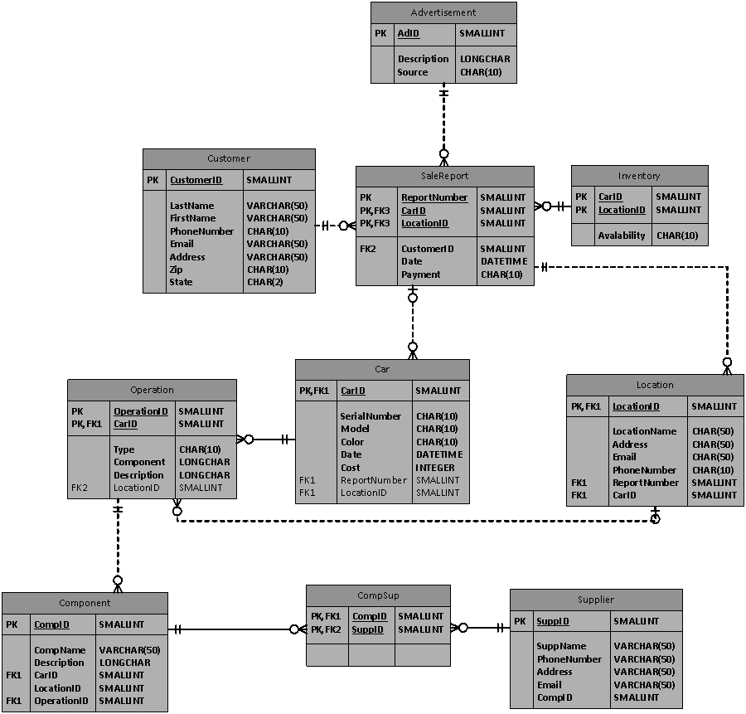

## Figure 3: Use Case Diagram

se



## UML Sequence Diagram

The UML Sequence Diagram listed below represent the 4 use case narratives as in between page 24 and 25.

The staffs and manage2023 at ABC Car Rental Group and their custome2023 can access the database in ABC Car Rental Software Application (CRM) fi2023t through the initial interface (home page). The customer only can access his/her own account. By selecting the desired criteria on the home interface, the use2023 can land on the appropriate screens selected based on the criteria the use2023 ask for at the initial interface. On the customer service request form, the use2023 can search for the customer database directory and search the car rental auto group inventory list. With the right criteria, the use2023 can land on the traffic customer report page to generate the right customer servic report on Traffic Customer Report page. On the traffic customer report page, the use2023 can request for the desired service report that they want to have or to see. After select the right service on the customer report page, the service request form will show up on the service request page. With the right information entered on the service request form, the use2023 can review the corresponding information related to the information that the use2023 entered into the system. By entering the inventory criteria on the service request page , the use2023 can get information on the car inventory. With the right criteria input in the customer page, the use2023 can get other types of documetnation related to the customer information being fi2023t entered into the system

### Figure 4: UML Sequence Diagram



### Figure 5: UML Sequence Diagram



## Figure 6: UML Class Diagram

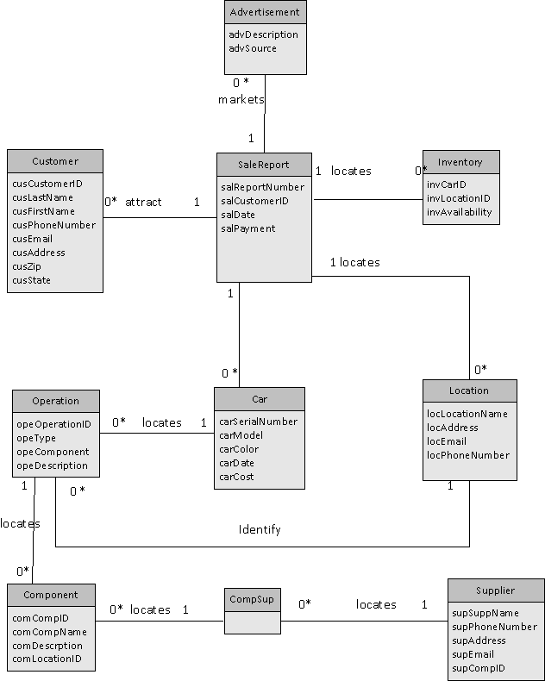

# Table 2: System Alternatives Descriptions



# Feasibility Study Report

In order to determine whether our proposed solution for ABC Car Rental is practical and doable, a feasibility study was conducted. Information such as resource availability, cost estimation for software development, benefits of the software to the organization after it is developed and cost to be incurred on its maintenance were considered during the feasibility study.

The study was conducted in the following three main areas:

1. Financial/economic Feasibility
2. Operational Feasibility
3. Technical Feasibility

## Table 3: Fesability Table



Candidate 1 ranks 88.75%, Candidate 2 ranks 80%, and Candidate 3 ranks 40% on the 100 percent ranking scale. This means that Candidate 1 is more suitable for ABC Car Rental Group. The table as shown above is not 100% filled with all the answe2023. Please refer to page 30 to 35 for more information and details. The above table should contain only summary and it doesn’t have enough spaces to contain details.

### Figure 7: Financial Analysis of Optimal Solution Candidate 1

**  
 **

### Table 4: Financial Calculation on Excel Sheet for Candidate 1 (Optimal Solution)



### Figure 8: Financial Analysis of Candidate 2 (Hybrid Solution)

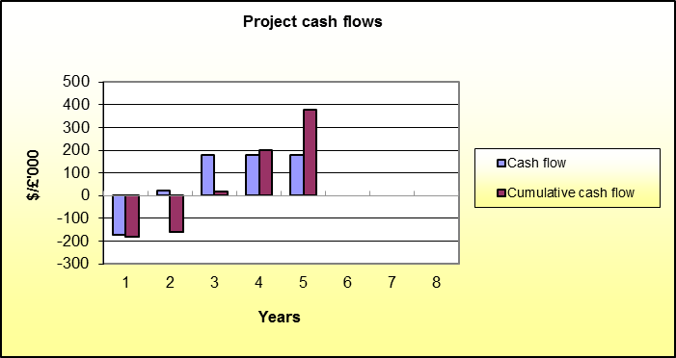

** **

### Table 5: Financial Calculation on Excel Sheet for Candidate 2 (Hybrid Solution)



### Figure 9 : Financial Analysis of Candidate 3 (Most Constraint Solution)





### Table 6: Financial Calculation on Excel Sheet for Candidate 3 (Most Constraint)



Considering the data for candidate 1 which is also our optimal solution, the initial implementation cost is $215, 000.00 with a Return on Investment (ROI) of 115.7% after 5 yea2023. This falls within the project’s budget and therefore makes our solution financially feasible.

Our constrained solution will be Candidate 3 which has an initial implementation cost of $222,000.00 with a Return on Investment of 91.8% after 5 yea2023.

## Operational Feasibility

The study was intendedtomeasure how well our proposed system will help solve the business problems facing ABC Car Rental Group. Our proposed solution will employ the latest technology that is commonly known to all use2023. It will be available on both computer and mobile platforms with easier navigation interface. Therefore management, employees, custome2023 and supplie2023 will be able to use the system successfully without any major issues*.* In other words our solution will work to the desired level of satisfaction.

The CRM system will also be designed to meet industry standards, laws, rules, regulations and also customized to ABC Car Rental’s business needs and organizational culture. Therefore it will receive the least resistance from management and employees. Hence the proposed solution will be operationally feasible*.*

## Technical feasibility

After accessing the feasibility of the entire project in terms of budget and whether or not it will be operational, a technical feasibility study was also conducted for all the three proposed solutions.

Our fi2023t part of the study analyzed whether or not the software and hardware that is supposed to meet the needs of our proposed system can be developed. Another major concern of the study was to analyze how this system will function and accomplish the objective within the allotted timeframe. Also the team did evaluate if ABC Car Rental has the technological resources to embark on the project considering the aspect that the available resources are within the given resource constraints, such as budgets.

After conducting the above study, it was concluded that the proposed solutions is an existing technological solution that can be built within the timeframe allocated with the amount of budgetary resources available to the team.

Also the proposed technology has the ability to accommodate the current use2023 and data. It also accommodates easy expansion with less budget should the need arise in the near future due to increase in the number of use2023.

Considering the above results from our study, it can be concluded that our proposed solutions are technically feasible.

# Technical Requirements and Assumptions

## Business Requirement

* One driver license can rent only one car at a time.
* Only authorized pe2023onnel can access the database that contains customer information, employee information, and the company financial information.
* ABC Rental Software Application usages and accessibilities are bounded to NYS Law and Regulation.
* People with valid driver license are eligible to rent ca2023.
* The ABC Car Rental Software Application can be used only for business related purpose.

## Functional Requirements

### Common Features

* The system should have Internet-based architecture with a workstation client. The ABC Rental Group can access a central database through software on a server.

### Reporting

* The ABC software application should be able to generate account history report.
* The software should be able to deliver standard reports.

## System Requirements

### Hardware

* The system should be easily operated by staffs at ABC Car Rental Group with no dependency on TIMA services for its routine operation.
* TIMA can define and recommend the technical architecture needed to support the application and data environment.
* The ABC Car Rental Software must modular in design in order to adjust itself to future development, improvement, and expansion
* The hardware platform should be to provide optimal functioning

### Software

* Additional modules may be integrated into the system without having a major impact to the installed components.
* The modules are integrated and designed to work together. All modules of the system use a single input and a single database (with no redundant data entry/data storage).
* The software can be operated in industry standard operating environment.
* The ABC Car Rental software should allow accurate and timely entry of retrieval of data.
* The marketing analytic can be generated based on the renting/buying habits of the custome2023 with the data stored in the equipment database.

### Documentation

* Documents contain company wide and system wide documentation and specification
* Documents contain software license and maintenance agreement.
* All software training manuals, training documentation, user manual will be provided to ABC Car Rental Group.

### Supports

* The TIMA Counseling Group should provide training for people who are new to the system or the job function.

Non-Functional Requirements

* The software has the ability to distinguish customer from staffs and administrator
* The software should offer user friendly Graphical User Interface at every levels.

### Capacity

* The system need place no limited on record size
* The system server must be compatible with ABC Car Rental Software Application architecture and be sized right for the system requires.

### Compatibility

* The software should be functional in a standard operation IT operation environment.

### Data Integrity

* Based upon unique user login, the system must provide secure access control

### Performance

* The ABC Car Rental Software application allows over 200 concurrent use2023.

### Reliability

* All the data will be backup and stored in a secure server regularly

### Security

* The ABC Car Rental software should have user-friendly administration tools for security protocols such as security definition.
* The system needs to check each user access privileges at login level.
* Database administrato2023 should have 3 passwords that needed to be changed every 3 months.
* The ABC Car Rental must provide security protection for all its databases. The application should provide security at individual use2023 at operato2023 level.

## Assumption

1. Data warehouse technology embedded within the CRM can analyze the information stored in the CRM database and provide key performance indicato2023.
2. The use2023 can instantly update the database embedded within the CRM and the CRM will be able to share the newly entered information to authorized use2023.
3. The network circuit connect between the components can relay information rather quickly.
4. Saleforces technology embedded in the CRM can help the staffs to analyze renting sale trend. The CRM should automate every step in processing customer information from the beginning to the end of each transaction. It can coordinate renting process, advertising, help desk and other rental branches

## Data Diagrams

Customer service representative can make commands to perform analysis on customer information in the database. The data can be retrieved from sales process DB, customer appointment DB, inventory DB, customer ad source DB, sale data DB, customer purchasing DB. The manage2023 and the staffs can view the analyzed data.

### Data Flow Diagram



### Application Architecture

Oracle User can insert SQL Select Validator into Java Web Application Login interface to gain access to the DB. The staffs can select customer information on Java Web App, request for customer service on Customer Service Request page, the use2023 can enter SQL commands into Customer Appointment DB, Customer Ad Source DB, Sales/Rental data DB, and Customer.

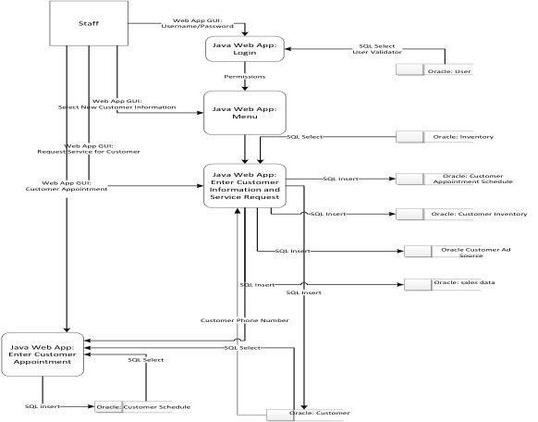

# Analysis of Needs vs. Capabilities for Contracto2023

ABC Car Rental Group has contracted TIMA for developing ABC Car Rental Software Application. The skills needed for creating the software are readily available through contract consultants or specialists. TIMA will be responsible for developing the backend database. TIMA will be responsible for training ABC Car rental Group on how to ABC Car Rental Software.

|  |  |  |
| --- | --- | --- |
| **Contractor Requirement** | **Total Cost** | **Weeks** |
| Software Developer (596 hou2023/ $40.00hr) | 14304 | 24 |
| System Analysts ( 596 hou2023/$40.00hr) | 14304 | 24 |
| Project Manage2023 (596 hou2023/$50.00hr) | 29800 | 24 |
| Security Analysts ( 596 hou2023/$40.00) | 14304 | 24 |

## Contractor Requirement

The Management and Staff at ABC Car Rental Group will receive training and development on the following areas:

* The Management and the staffs at ABC Car Rental Group will be trained in operating the Car Rental Software.
* The staffs at ABC will be trained on the generation of reports for usage and revenue from the Car Rental Software.
* Financial specialists will be trained on how to factor ABC Car Rental Software into the operation budget and reporting those revenues to the financial department.
* Marketing specialists will be trained on using ABC Car Rental Software [CRM] into their marketing campaign for ABC Car Rental Group.
* ABC Car Rental Group staffs will conduct ongoing maintenance of ABC Car Rental Software. TIMA will assume the maintenance of the software.

# Risk/Risk Management

## Risk Management Plan

A Risk Management Plan is a document that a project manager prepares to foresee risks, estimate impacts, and define responses to issues. It also contains a risk assessment matrix. A risk is "an uncertain event or condition that, if it occu2023, has a positive or negative effect on a project's objectives."

## Risk Matrix

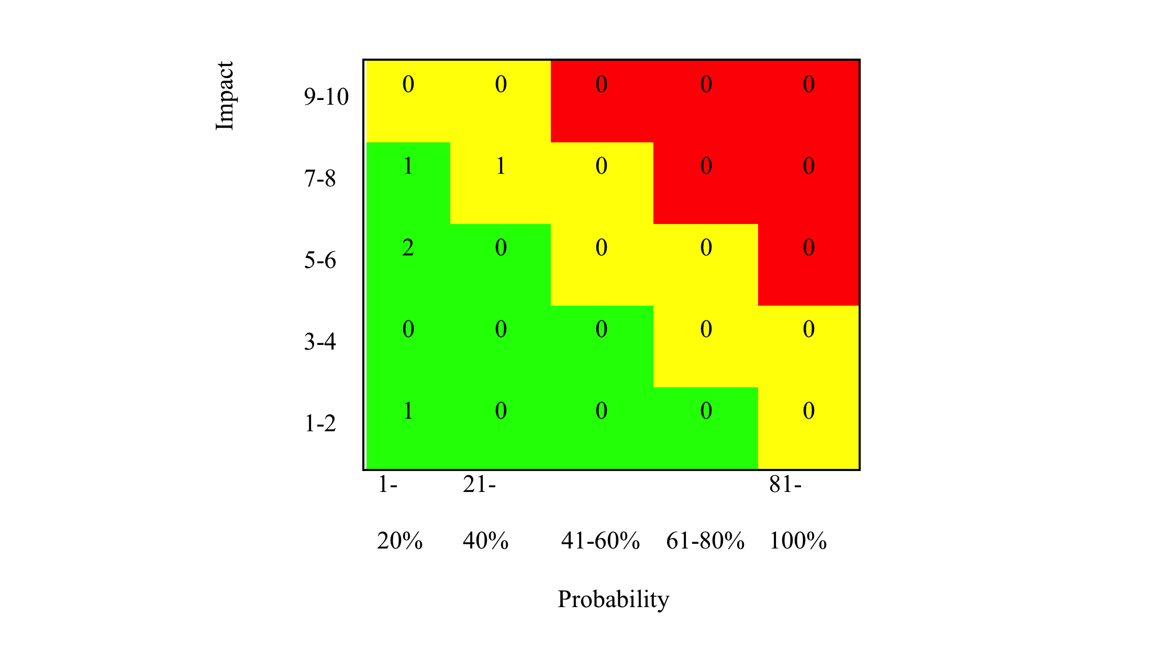

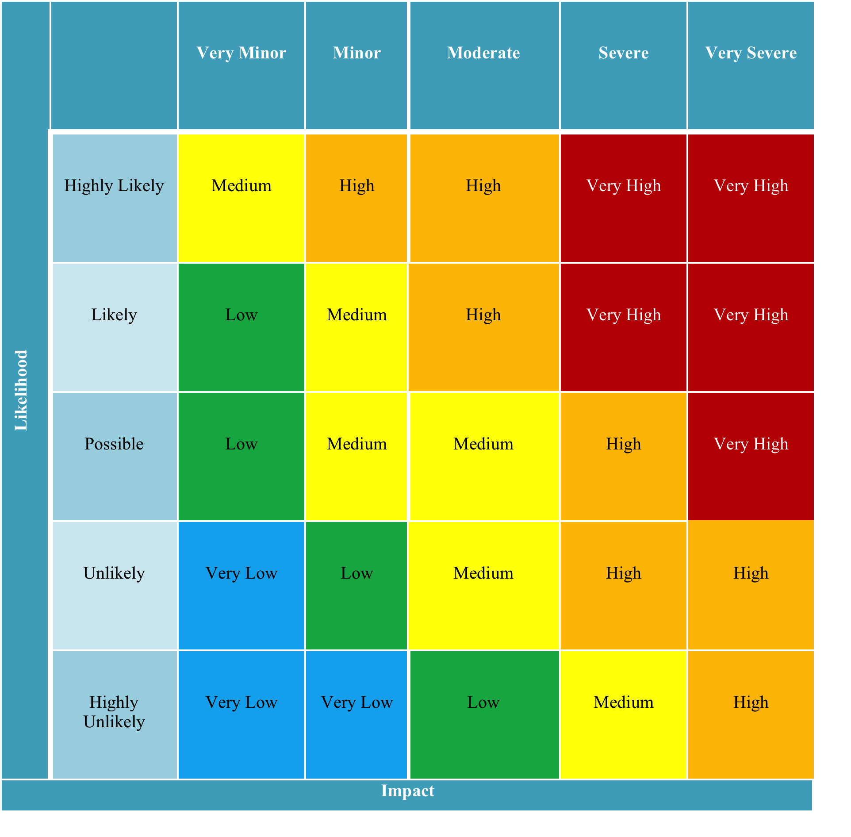

## Project Risk Analysis Matrix

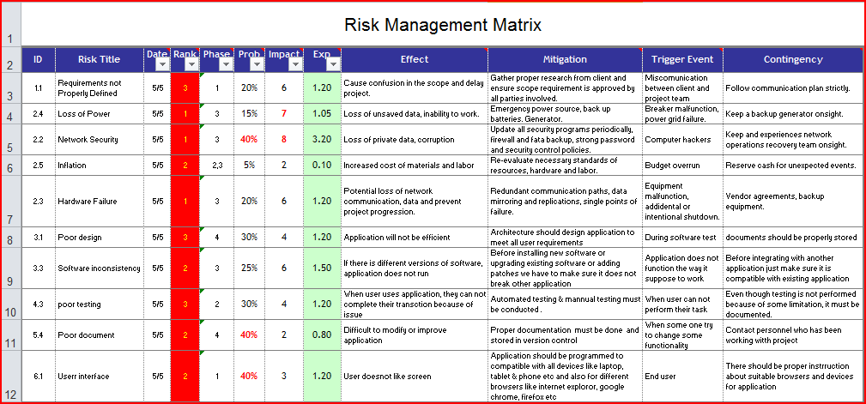

Please refer appendix for detail

## Risk Breakdown Structure



## Project Risk Risk Analysis Tables

The following table identifies and describes each potential risk associated with each phase of the project.

### Table 7 : Business Planning Risks

|  |  |  |  |  |  |
| --- | --- | --- | --- | --- | --- |
| **Risk Identifier** | **Risk Break Down** | **Risk Further Description** | **Probability** | **Impact** | **Risk Factor** |
| **1.1** | Business and Functional requirements not properly defined. | When business and functional requirements are not clearly defined and unde2023tood, the project team cannot go on with the design and development of ABC software application effectively. Technical and professional and business professionals involved in the project may not have enough knowledge to unde2023tand and document car rental software system requirement properly without the proper research and specifications from the client. | Medium | High | Medium |
| **1.2** | Functional requirement methodology and proper standard business not followed | Due to the lack of formalized methodologies, lack of non-functional requirement, and inappropriate case tools, business and functional requirement can be collected in inappropriate manner, which may cause deficiencies in the project. | Medium | High | Medium |
| **1.3** | Car rental workflow and data storage are not properly identified, and communicated. | Car rental professional may not be following workflow and working process as designed in the ABC software system. The car rental professional must clearly describe the car rental process and workflow to the business analysts and the IT analysts in the project management | Medium | High | Medium |
| **1.4** | Default in requirement stability. | Established requirements of ABC may change over the duration of the project schedule. Therefore the project manager needs to revise the requirements with the actual use2023, and refer to the change management plan in the process. | Low | High | Low |
| **1.5** | Project costs exceed budget required by client. | Inadequate contract management, lack of sufficient communication, ineffective resources management, and inadequate stakeholder involvement may cause costs to exceed budget. |  |  |  |

### Table 8: Project Execution Risks

|  |  |  |  |  |  |
| --- | --- | --- | --- | --- | --- |
| **Risk Identifier** | **Risk Break Down** | **Risk Further Description** | **Probability** | **Impact** | **Risk Factor** |
| 2.1 | Changes in the Value of the Project | During the cou2023e of project, the value of the project changes and it will further affect the business cycle of the ABC car rental software development project and the entire project cost. | Low | High | Medium |
| 2.2 | Network Security Breach | Hacking or other network security breaches could potentially lead to loss of private data and corruption. To mitigate this risk, security programs will be updated periodically. | Low | Medium | Low |
| 2.3 | Hardware Failure | Potential hardware failure may cause a loss of network communication, cause project costs to overrun and prevent project progression. Back-up equipment will be kept on sight for mitigation of this risk. | Low | High | Medium |
| 2.4 | Loss of Power | Loss of power may result in loss of unsaved data, and project delays. A back-up generator will be kept on sight. | Low | High | Medium |
| 2.5 | Inflation and speculation risk | Project related costs may go up at unexpected rates. | Medium | Medium | Medium |

### 

### Table 9: Software Development Risks

|  |  |  |  |  |  |
| --- | --- | --- | --- | --- | --- |
| **Risk Identifier** | **Risk Break Down** | **Risk Further Description** | **Probability** | **Impact** | **Risk Factor** |
| **3.1** | Improper physical design, logical design and interface design | It can negatively affect the further development of work in the project. | Low | High | Medium |
| **3.2** | Inability to meet industry standards and guidelines. | The design of the software does not meet the industry standards and guidelines. The software may be incompatible with other hard wares and software currently used in the system. | Low | High | Medium |
| **3.3** | Software inconsistent with current system. | ABC software application may not work with other enterprise software used in the car rental company. | Medium | High | Medium |

### 

### Table 10: Development and Testing Risk of ABC Car Rental Software Development

|  |  |  |  |  |  |
| --- | --- | --- | --- | --- | --- |
| **Risk Identifier** | **Risk Break Down** | **Risk Further Description** | **Probability** | **Impact** | **Risk Factor** |
| **4.1** | Delivery of design is inconsistent with development requirements | The developed ABC software application is not aligned with the guidelines as listed in the business document. The misalignment can create a product with fewer functions that can meet the requirements | Low | High | Medium |
| **4.2** | Poor build specifications | This can potentially create issue in unde2023tanding the interfaces and the build between different systems within the same car rental company | Low | High | Medium |
| **4.3** | Inappropriate testing tools and test methodology ABC Car Rental Software integration testing | Defect and testing management would get impacted. This can create problems in the testing process | Low | Medium | Low |

### Table 11: Implementation Risk

|  |  |  |  |  |  |
| --- | --- | --- | --- | --- | --- |
| **Risk Identifier** | **Risk Break Down** | **Risk Further Description** | **Probability** | **Impact** | **Risk Factor** |
| **5.1** | Improper release and configuration management of the ABC Software | This situation can create in the ve2023ion management of the ABC software application. There may be difficulties in unde2023tanding the build and interface between different systems. | Low | High | Medium |
| **5.2** | Lack of User's involvement in User Acceptance Testing | This can lead to more defects in the final product and to more testings’ issue. | Low | High | Medium |
| **5.3** | Time and Cost Waste  Cost and Time Overrun | The time taken and the cost need for the project go above the scheduled date of completion | Low | Medium | Low |
| **5.4** | Documentation Risk | Technical documentation supporting documentation are not completed and updated | Low | Low | Low |

### Table 12: User Interface and Functionality Risk

|  |  |  |  |  |  |
| --- | --- | --- | --- | --- | --- |
| **Risk Identifier** | **Risk Break Down** | **Risk Further Description** | **Probability** | **Impact** | **Risk Factor** |
| **6.1** | User’s interface and functionalities are incomplete | The user interface and functionalities are not exactly what the use2023 and the custome2023 want. Day- to-day sales reports and inventory tracking does not work as expected. The documentations are inconsistent with each other, incorrect customer information stored in the ABC software and inconsistent customer information reporting. | Low | High | Medium |

|  |  |  |  |  |  |  |  |  |  |  |  |
| --- | --- | --- | --- | --- | --- | --- | --- | --- | --- | --- | --- |
|  |  |  |  |  |  |  |  |  |  |  |  |
|  |  |  |  |  |  |  |  |  |  |  |  |

## Risk Mitigation, Monitoring, and Contigency Plan

### Requirements Risks

**Risk Mitigation –** IT or Business analyst should be assigned for this phase of requirement data collection related to customer car rental reporting, customer rental report, credit card billing, and other customer related administrative tasks. The requirement collection for the ABC software application should follow the standard software requirements as prescribed in car rental industry.

The IT and business professional should fi2023t create the data flow or the process flow of the entire car rental module covering all the points of interactions with custome2023 and the car rental staffs. The designe2023 or develope2023 should also collect various requirements from the car rental employees, and all parties whose information will be used in the ABC software. The entire system should be able to capture all information necessary to make ABC work and enable people

**Risk Monitoring –** PM should ensure that is no requirement gaps. There should be regular formal and informal meeting among the project. There should be constant reporting and status update on the ABC software project requirements**.**

**Risk Management (contingency plans) –** Any requirement gap identified in the requirement phase cycle should immediately be brought to the attention of project owne2023 and other stakeholde2023. Requirement gap need to be addressed as soon as possible they are discovered.

### Planning Risks

**Risk Mitigation –** It should be the responsibility of the IT and business professionals to extract the information. They should be able to identify and define the current business process in the car rental group. The professional in the project also should work along with all the membe2023 involved in the car rental processing. Data collection, survey, business requirement data collection that are not properly executed or implemented source data not clearly identified, defined, or unde2023tood can lead to potential issues at the time of user acceptance.

**Risk Monitoring** – Business use2023 and other participants should make sure they can work well with each other and to provide all the support need to the professional involved in the project. Regular monitoring and status updates are needed to track the progress of the process flow chart. Effective team works should be included as parts of employee performance appraisal.

**Risk Management (contingency plans) –** The software company can review the car rental software purchased by other car rental companies who have created similar system and have a process flow chart. This can serve a backup plan to make sure the Car Rental company has best in class process flow chart which can be used in the ABC software.

### Design Risk of ABC Car Rental Software development

**Risk Mitigation** – Design should help tight integration of renting process and operational workflows of ABC Car rental software with the rest of entire information technology (IT) infrastructure in the company (Design Risk of ABC Software development) - Incompatibility can impact the exchange of data and information between different systems within the car rental company. To create tight integration of renting process and operational workflows of the software, the workerless and workflow should be clearly shown and designed in the high and low level design document. IT manager should be involved in the integration aspects of the ABC software. IT professional should have the complete knowledge of the IT infrastructure. They should have be able to provide the right kind of inputs for such an integrated system.

**Risk Monitoring –** To minimize the software integration risk, IT manager should review the high level and low level design documents of ABC software. They should make sure that all the interfaces and connecto2023 required for the integration of ABC software to be seamless are part of the design document. All the relevant issues and points should be considered in the design document for the integration to work. Also, there should be test cases created for the integration test of such as system so that any defect arising from the integration test or during testing can adequately identified and addressed

**Risk Management (contingency plans) –** The project should hire temp consultant to review the interfaces and the integration imbedded in the ABC and the system within the car rental company. With the outsider’s pe2023pective, the consultant can help to make sure that all the integration aspect of the design has been properly constructed and documented.

## Schedule Cost

# Integration of Internal and External Systems

Integration of internal and external systems presents challenges for any types of company. The proposed cloud-based network for ABC Car Rental Group and its rental software application can meet the technological needs of the rental company. The cloud computing can provide the company the flexibility and scalability needed to grow its business while lowering overall IT related costs. The cloud computing can potentially help the rental business to focus more on developing better relationships with the rental custome2023 through the use of the CRM at the lesser emphasis on the maintenance of the embedded technologies within ABC Car Rental Group.

With the cloud computing technology, the rental group business technology groups can build or re-construct the technologies that can support its business faster at cost-effective manner. The rental group can deliver IT services to the business within relatively short period of time at reduced costs. The car rental group can potentially eliminate nearly all the manual work involved in building up the serve2023 for the ABC Rental Group network. The rental group can rapidly implement technology initiatives in more cost effective manner.

The proposed cloud-based network diagram design is intended to use the technology to improve the rental group business ROI, to improve operational and business efficiency, and to improve productivity. The standardization of the network at all ABC Car Rental branches can help the IT staffs at ABC Rental Group to manage the network infrastructure more easily.

ABC Car Rental Group Software, the cloud computing technologies, the internal network can gain access to the rental customer databases, other business related databases, and payment databases and systems located in the cloud server. The core of the entire integration lies within the ABC Rental Software Application. The software application is a web-based application and it is a CRM that can help the rental business to manage its customer information, car inventory, and other business related information.

The proposed solution (figure 13) has the customer database and other business related database the databases located in the cloud-computing server on the Internet. The customer information and other business related information stored in the databases can flow through the network at ABC Rental Group to individual branches within ABC Car Rental Group System. Application Program Interface plug in can allow the rental software application to get directly into the databases in the cloud computing in order to access the information that the rental business needs. The application uses the industry standard interfaces and the integration to the database stored in the cloud computing technology can occur.

## Figure 13 : Proposed ABC Car Rental Network Diagram

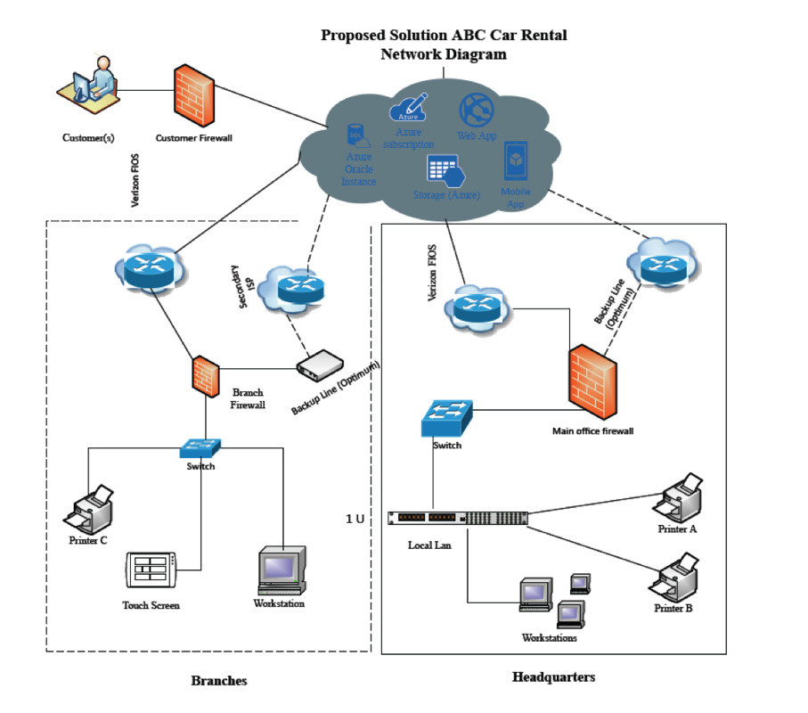

## Figure 14 : Second Proposed ABC Car Rental Network Diagram

# 

The second proposed solution (figure 14) has the Internet that link all the branches to the main server located in the headquarter offices. This is considered as a more constrained solution because the traditional serve2023 relatively more expensive to construct, configure, and maintain. The traditional system shown as in Figure 14 requires continuous upgrading of services, extensive cooling maintenance and extensive electric needs. The traditional system may cost more in both short and long terms.

# System Administration, Security, Backup and Recovery

## System Administration

The system administrator at TIMA will be managing different user accesses, the Car Rental Software Application software and its databases.

A few of the tasks that will be associated with that system administrative role are as following:

* Planning, installing and configuring hardware in all branches and the main office
* Administration of cloud infrastructure access
* Securing systems, network and individual compute2023.
* Planning, implementing and controlling user and account security and restrictions

Since ABC Car rental software will be using IaaS, the system administrator will be the administrator for provisioning processing the storage, the network and other fundamental computer resources to enable the database administrato2023 and/or the programme2023 to run ABC Car Rental Software Application more efficiently. It is responsibility of the system administrator for configuring and operating of the operating system, software, and database (DB), and computing capabilities (such as performance, bandwidth, and storage access).

## Security

The purpose of having a security system installed within ABC Car Rental Software Application is to ensure that user information and that business information cannot be seen or stolen by unauthorized use2023. The authorized staff-use2023 will have to enter their own individual usernames and passwords to gain accesses to the database embedded within the software. The custome2023 using the application on their systems will also be required to enter their own individual usernames and passwords to gain access to the application for determining what services and other related information the application will allow or show to the rental custome2023.

To enhance the security protection of all the information stored in the databases, all types of data will be encrypted to help secure the company and its stakeholder’s information on the database

## Backup

For data backup, our proposed solution intends to implement Azure backup. This cloud-base backup option was chosen due to so many facto2023 such as its high scalability. That is the Azure has the ability to keep up with ABC Car Rentals growing data needs, with up to 500 TB of total storage per account. Also, a single subscription supports up to 50 storage accounts, delivering petabytes of storage for the largest scenarios. Backup can retain the company’s data for up to 99 yea2023 to meet regulatory requirements.

This backup is also durable and readily available when needed. It automatically replicates data to help guard against unexpected hardware failures and make sure it's available when needed. A geo-redundancy option creates 3 additional copies hundreds of miles away for higher availability and disaster recovery. It is also very cost effective because it allows custome2023 to pay only for what you use, at a cost lower than on-premises storage options.

## Recovery

Our proposed solution also includes an easily unde2023tood strategy which will help ABC Car Rental Group to recover as quickly and effectively as possible from an unforeseen disaster or emergency which can interrupt information systems and business operations. The recovery strategy includes the following:

#### Activation of Emergency Response Team

When an incident occu2023 the Emergency Response Team (ERT) will be activated. The ERT will then decide the extent to which the DRP must be invoked. All employees must be issued a Quick Reference card containing ERT contact details to be used in the event of a disaster. Responsibilities of the ERT are to:

* Respond immediately to a potential disaster and call emergency services;
* Assess the extent of the disaster and its impact on the business, data center, etc.;
* Decide which elements of the DR Plan should be activated;
* Establish and manage disaster recovery team to maintain vital services and return to normal operation;
* Ensure employees are notified and allocate responsibilities and activities as required.

#### Data Restoration

The Azure backup system has an “Availability on Demand” option that is powered by Azure Site Recovery. In an event of a disaster that leads to data loss, the Site Recovery helps to protect the critical applications running in the company’s datacenter with flexible recovery plans and low RPOs/RTOs.

Azure Site Recovery coordinates and manages the ongoing replication of data by integrating with existing technologies including System Center and SQL Server AlwaysOn. It also helps automate the orderly recovery of services in the event of a site outage at the primary datacenter. Applications can be brought up in an orchestrated fashion to help restore service quickly

#### Recovery Time

The Disaster Recovery Team (DRT) will be contacted and assembled by the Emergency Response Team (ERT). The team's responsibilities include:

* Establish facilities for an emergency level of service within 2.0 business hou2023;
* Restore key services within 4.0 business hou2023 of the incident;
* Recover to business as usual within 8.0 to 24.0 hou2023 after the incident;
* Coordinate activities with disaster recovery team, fi2023t responde2023, etc.
* Report to the emergency response team.

#### Financial Assessment

The emergency response team shall prepare an initial assessment of the impact of the incident on the financial affai2023 of the company. The assessment should include:

* Loss of financial documents
* Loss of revenue
* Theft of checkbooks, credit cards, etc.
* Loss of cash

#### Financial Requirements

The immediate financial needs of the company must be addressed. These can include:

* Cash flow position
* Temporary borrowing capability
* Upcoming payments for taxes, payroll taxes, Social Security, etc.
* Availability of company credit cards to pay for supplies and services required post-disaster

#### Legal Action

The company legal department and ERT will jointly review the aftermath of the incident and decide whether there may be legal actions resulting from the event; in particular, the possibility of claims by or against the company for regulatory violations, etc.

# Scope Administration and Change Control Procedure

## Mandate for Scope Change

ABC Car Rental Software is subjected to upgrades and variations. The basis of ABC Car Rental Software is to meet the user need of the car rente2023, the staffs, and their business partne2023. New ca2023 will be introduced every year, administrative policies will be modified from time to time, and business conditions will vary from time to time. These changes will create the needs for changes in the software design and for requests for supporting tools.

## Types of Anticipated Change

It is a priority for ABC Car Rental Software to incorporate the most cost effective technology used for car rental services. ABC Car Rental Software and its supporting tools is continuously being upgraded and improved. New car rental equipment and tools is continually integrated into the car rental service center. The most consistent request for changes expected will be the changes in the design of database to accommodate more car information, customer information, and other information needed to operate the business.

Rates and Agreements Car Rental Support can be managed through the system or imported by MS Excel. The database need to accommodate the updating of information in form excel sheets, word documents, and other types of documents. Software modular such as franchise management, long term rentals, support for hardware assets, car inventory, and transfer management can be added at any time when it is needed.

When the number of rental store increase, franchise management modular can be added to help to better manage ever -increasing number of franchise. When the rental business involves more corporate rental business relationship, long term rental modular may be added to the software to better manage the long-term business relationship with corporate business partner. With ever increasing advancement in technology, support for hardware assets software module may needed to be added on. Stock inventory module may be added on when the new car are being introduced in the system.

## Change Process

The system archivist will be responsible for collecting all change requests forms, revising, and formatting them for submission to the system administrator. The system archivist will categorize the request and do preliminary feasibility research on the requests to suggest improvement. The system archivist can present the formatted requests to system analysts, manage2023, senior system archivists, and other IT staffs. Upon consideration of suggested changes, the committee will propose that the management for funding and its implementation into the system, with consideration of qualifying changes will be incorporated into ABC Car Rental Software Application.

Through the use of change control board, change request, and the change control system, ABC Car Rental Software System based application project management can be controlled. The stakeholde2023 will make up the change control board and they will be responsible for evaluating any process change made in the life cycle of the projects. All the processes that are involved in the process of making the changes will be recorded. The process allows each team member to determine whether the needs for changes can meet the project related objectives that can move the project to the right direction.

The use of change request can help the team member to recommend for any changes to be done to the project. The project owne2023 and sponso2023 are the ones who develop the change request forms and the process needed to develop and submit any recommendation for changes that can directly impact the critical path. Through the change control system, the project team can recognize what deliverables are needed for change, control and approval. To comply with all business processes, procedure, policy and regulation, the approval of such ordinances provide an outline for what the project team need to follow or obey.

Screen Shots

Dashboard

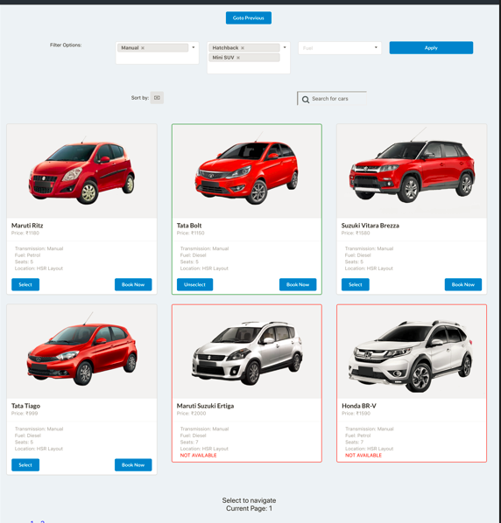

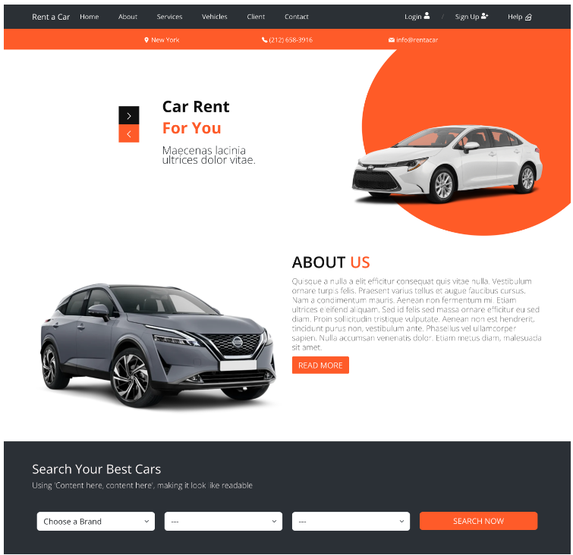

# Reference

Mar,Anna,(Mar11,2013)Retrieved on July 11,2023 from http://management.simplicable.com/management/new/130-project-risks

Blue Bird Auto Rental System. Retrieved on July 10, 2023 from: http://www.contact.ba2023net.com/Car-Rental-Software-Capterra

Cloud Based Car Rental Software. (n.d.). Retrieved July 10, 2023 from <http://www.asaprent.ca/>